[DCO-2450] Motive Financial - Authenticated Customer "Add Phone Number" lacks sufficient contrast Created: 30/Apr/24 Updated: 03/May/24
Status: | In External Review
Project: | Journey Manager
Components: | None
Affects versions: | None
Fix versions: | Accessibility

Type: | Story | Priority: | None
Reporter: | Sanya Khandhuja | Assignee: | Fusi Olateru
Resolution: | Unresolved | Votes: | 0
Labels: | Motive, MotiveAuthenticated
Remaining Estimate: | Not Specified
Time Spent: | Not Specified
Original estimate: | Not Specified

Attachments: | image-20240430-204459.png
QA Bug Count: | 0
Days Open: | 1 days
Bug Count: | 0
Hours Variance: | 0
Hours Remaining: | 0
Hours Target PMO: | 0
Sprint:
Days Open: | 1

Description

The description information (grey on grey) below the add a phone number text lacks
sufficient contrast, the contrast between the foreground and background text colors is
insufficient (2.3:1), falling short of the 4.5:1 required for regular text.
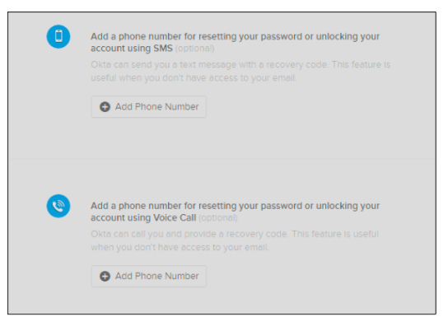
■ Recommendation: Change all problematic foreground/background pairings to higher
contrast ratios that meet or exceed the required minimum.

Comments

Comment by Fusi Olateru [ 03/May/24 ]
okta - Probably connot be modified. Page will be upgraded when go to OIE (Upgrade/Next version of Okta)
Generated at Mon May 06 21:49:59 UTC 2024 by Ian Hicks using Jira 1001.0.0-SNAPSHOT#100252-rev:aa264b414382dcd2bbea0c3e63c78e358e7de0d5.

